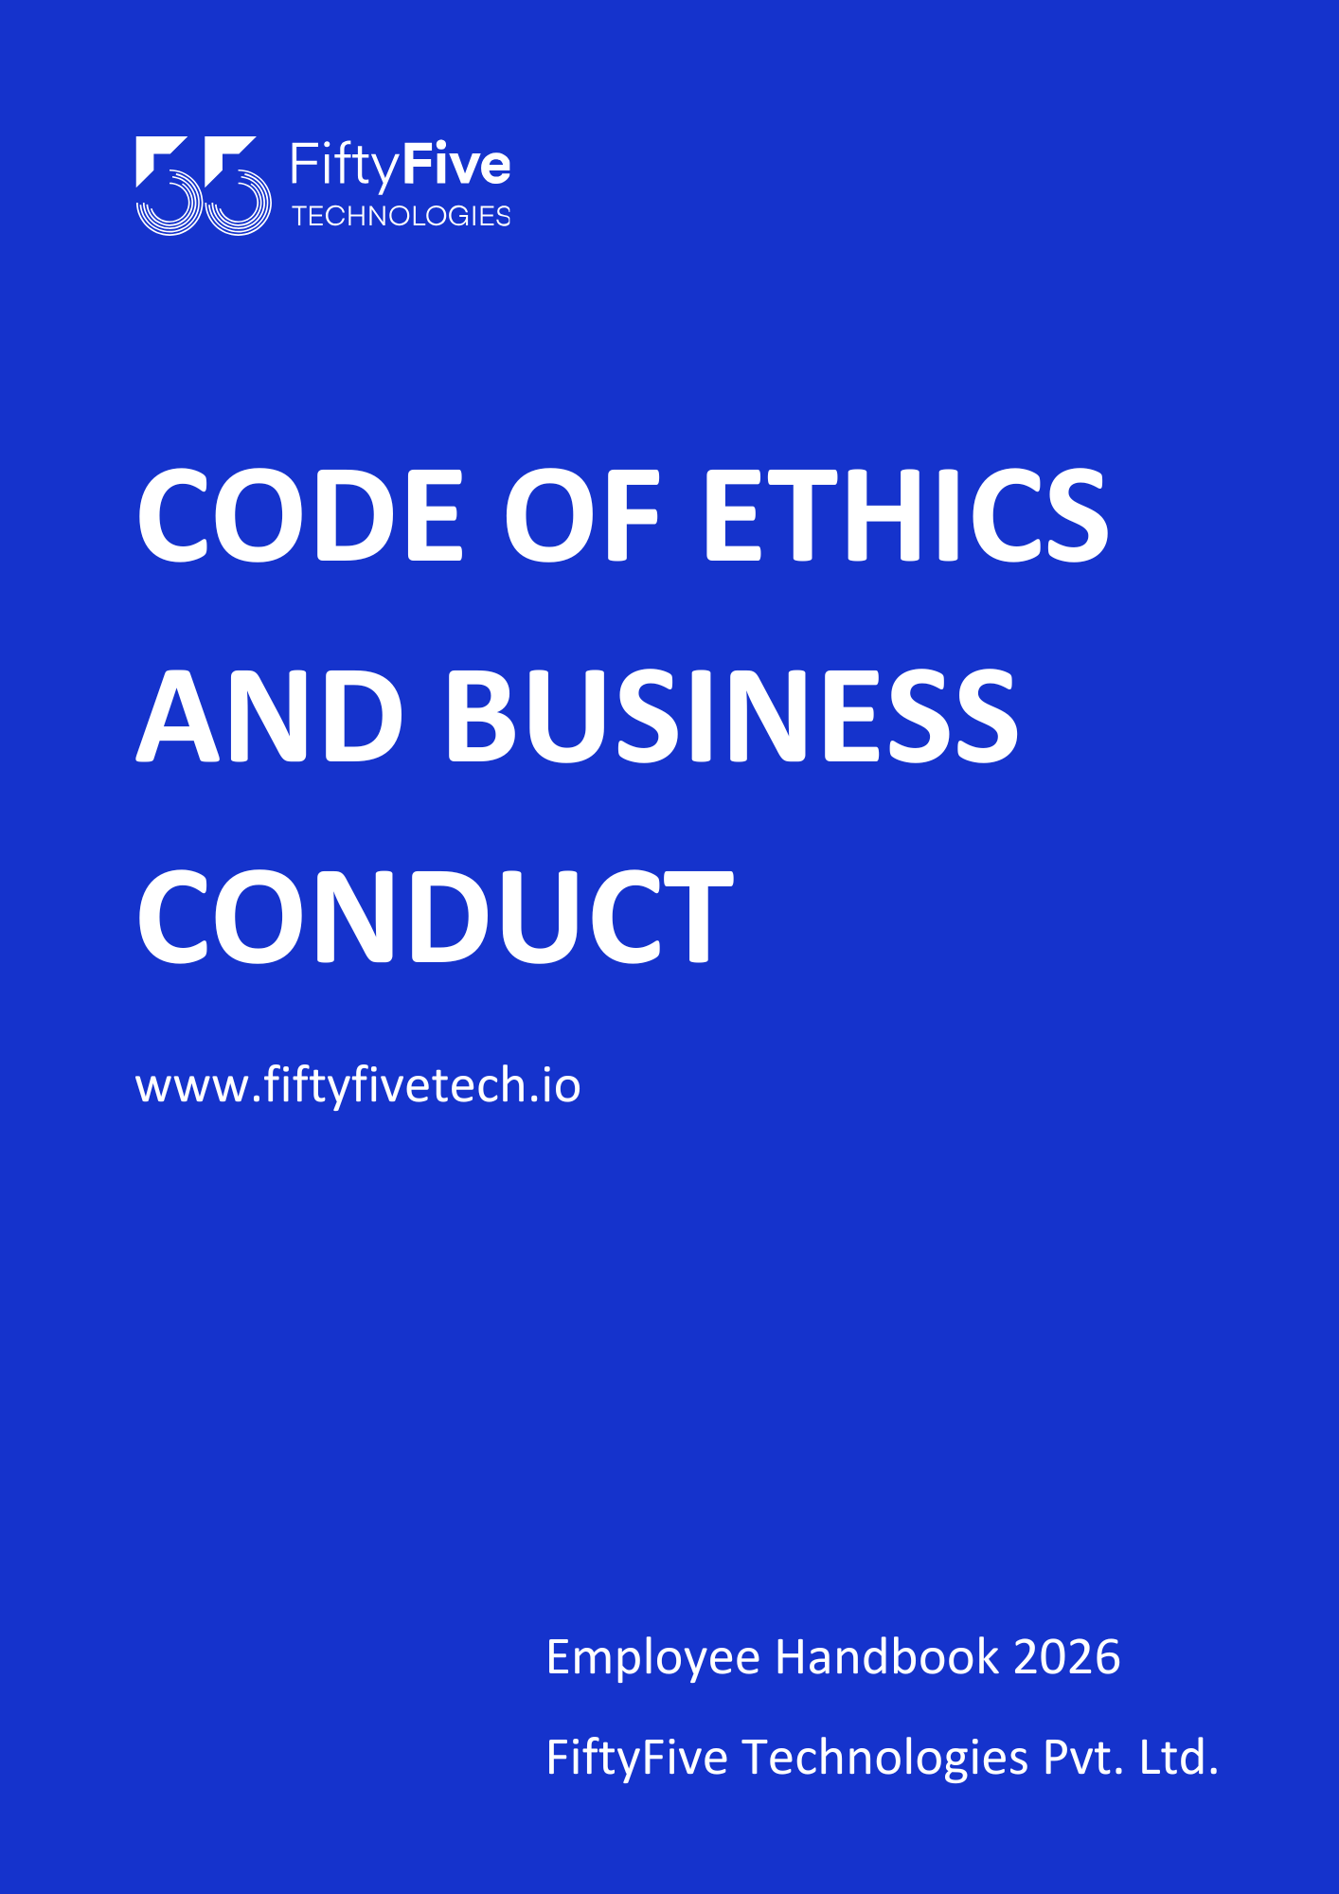

Code of Ethics & Business Conduct
Document Release Notice

This FiftyFive Technologies Policy, Code of Ethics & Business Conduct is released for use in FiftyFive Technologies Pvt Limited with effect from 01 January 2026.
This document is subject to FiftyFive Technologies Pvt Limited Procedure and subject to change any time as per the company policy.

Approved By: Jyothi Sharma (CEO-FiftyFive Technologies Pvt. Limited)
Approved By: Sanchi Saxena (Head HR-FiftyFive Technologies Pvt Limited)

For all employees, the following guidelines/code of conduct are applicable:
CODE OF ETHICS & BUSINESS CONDUCT
Statement
This Code of Ethics & Business Conduct (CEBC) applies to all employees working at FiftyFive Technologies, its subsidiaries, and joint ventures over which FiftyFive Technologies exercises management control ("We", "Us. Our. "Company").
Our Code has been created to help support employees working with the Company. This code is to maintain and reinforce required standards of behaviors for the effective working of our company to provide an inclusive environment to all our employees and is a step in the direction of protecting the interests of all stakeholders.
Objective
To provide a performing, inclusive, safe, and growth-oriented environment for all employees in FiftyFive Technologies through this CEBC. This policy states the expected behaviors of every employee while and during employment with the company.
Scope
The behaviors at the workplace are critical in delivering the desired results in all our roles impacting our performance and growth, hence, it is critical for every employee to follow this code very meticulously. The violation of the code may call for investigation, warning, censure, transfers (departments, location, or roles), demotions, holding of salaries and benefits, and in serious violations including termination of employment.
Definitions
Employees: Full-time employees, Interns, Trainees, Consultants (Full and part-time), and contractors. Behaviors: Actions taken at the workplace during the time of employment with the company including all commissions and omissions.
Workplace: All offices, remote workplaces, client locations, online environments, such as the Internet, and any other place where any official work/meeting is being conducted.
Code of Ethics & Business Conduct: Guidelines for behaviors during employment with FiftyFive Technologies.
Conflict of Interest: A “conflict of interest occurs when an employee’s activities, transactions, interests, influences and/or relationships, both inside and outside of the company interfere in anyway with the employee’s performance of their job duties or the interests of the Company as a whole.

- Employee Data Privacy
- The Company is committed to protecting the privacy and confidentiality of employee personal data. Employee information is collected, processed, and stored only for legitimate business, employment, legal, and compliance purposes. These purposes may include recruitment, onboarding, payroll, benefits administration, performance management, IT and information security, and statutory or regulatory reporting.
- Access to employee data is strictly restricted to authorized personnel on a need-to-know basis. The Company implements appropriate technical, administrative, and organizational safeguards to prevent unauthorized access, misuse, loss, or disclosure of employee information.

- Employee data may be shared with third parties only where required by applicable law, contractual obligations, or legitimate business necessity. Such data shall be retained only for as long as necessary to fulfill its intended purpose or to comply with legal requirements.
- Employees are expected to safeguard personal and Company data at all times and must promptly report any suspected or actual data breach, unauthorized access, or misuse to the HR Department immediately. Accessing another employee’s personal information through Company platforms or portals without the consent of the concerned employee or without official authorization is strictly discouraged and may lead to disciplinary action.

- Conflict of Interest
A “conflict of interest occurs when an employee’s actions, transactions, interests, and/or relationships, both inside and outside of the company interfere in any way with the employee/team/company’s interests and work.
The following are some examples of conflict-of-interest situations:
Any activity that may oblige one to an outside entity such as a supplier or a customer.
  - Holding a financial interest in a competitor or vendor company of FiftyFive Technologies where one could personally affect the business with that company. Financial interest could include, ownership of capital stock, bonds, or notes; partnership interest; direct or indirect interest through a family member, trust or other relationship.
  - Working on a part-time, temporary basis, moonlighting, freelancing, or providing advisory consultancy to another organization/person/business.
  - Any activity carried out with the support of or through family or friends for mis-utilizing the company resources, facilities, and equipment.
  - Receiving disproportionate/special gifts, discounts, and benefits, which are not generally offered by an outside concern while being in a position to influence the company decisions.
  - Working with any not-for-profit entity where you can influence the company's investment decisions.
  - Preferential hiring, promoting, supervising, directing business to, investing in, or in any other manner favoring a family member or friend, without the prior written consent from the management.
Note: On occurrence/potential occurrence of such conflict, the Employee shall disclose such information to their supervisor/manager over mail; Try and avoid entering such a transaction without the guidance of the supervisor/manager. The appropriate parties will decide to determine if the conflict is substantial enough to exclude the Employee from any further involvement in such activity or decision process.

- Maintaining Accurate Records
The employees are mandatorily required to keep accurate, complete information in a timely manner to:
  - Meet our legal obligations.
  - Ensure any reports that are based on those records are also accurate and complete. The records include all work-related documents, emails, spreadsheets, notes, reports (including timecard records and operating metrics), financial records, plans, procedures, and process documents, business information, including engagement documents and deliverables, payroll records, performance evaluations, and time and expense reports.
Note: The security of these documents is also the responsibility of the concerned employee.

- Protecting Customer Data
Leaking, manipulating, mismanagement, stealing or mishandling of any customer data, be it confidential or otherwise is strictly prohibited. Employees deployed on projects are trusted with sensitive information considering that they have understood all the clauses of the Non-Disclosure Agreement (NDA).
The NDA restricts the employee to:
  - Share/disclose client information whether during or after their employment with FiftyFive Technologies.
  - Use the information for any kind of benefit (personal or otherwise) or engage with an entity relating to the employer’s business, during their employment and till 12 months of their separation from the company.
  - Publishing the customer data, code, or any other documents of the company on platforms such as GitHub is not only prohibited but also illegal.

- Protecting Intellectual Property Rights
The intellectual property of FiftyFive Technologies is a strategic and valuable asset and must be adequately protected. Intellectual property includes, but is not limited to, patents, copyrights, trademarks, trade secrets, inventions, software source code, designs, documents, methodologies, data, and all work products created during the course of employment.
Employees are expected to take all necessary steps to protect the Company’s proprietary and confidential information and to respect the intellectual property rights of others. In certain circumstances, employees may be required to share confidential information with third parties such as customers, vendors, or suppliers. Any such disclosure must be made with utmost care and strictly in accordance with the Company’s policies, approvals, and processes.
Unauthorized use, copying, distribution, or disclosure of intellectual property—including software, proprietary tools, or training materials—is strictly prohibited and may be illegal.
Confidentiality and intellectual property obligations continue even after the termination of employment. Any violation may result in disciplinary action, including termination, and may also lead to legal consequences.

- Anti-Money Laundering
Definition of Money Laundering
Money laundering refers to any process used to disguise the origin of illegally obtained money to make it appear legitimate. This includes, but is not limited to:
- Concealing the source of funds
- Converting illegal money into legal assets
- Using Company resources or systems for unlawful financial transactions

Employee Responsibilities
All employees are required to:
- Act with integrity and honesty in all financial and business dealings
- Ensure that Company funds, reimbursements, and transactions are used only for legitimate business purposes
- Follow all internal financial controls, approval processes, and documentation requirements
- Complete any mandatory AML or compliance training provided by the Company

Prohibited Activities
Employees must not:
- Engage in or facilitate money laundering or financial fraud
- Accept or process funds that are suspected to be from illegal sources
- Create false invoices, expense claims, or financial records
- Circumvent financial controls or approval mechanisms
- Assist any individual or entity in hiding or misrepresenting the source of funds
Identification and Reporting of Suspicious Activities
Employees must immediately report any suspicious activity, including but not limited to:
- Unusual or unexplained financial transactions
- Requests to process payments without proper documentation
- Pressure to bypass standard approval or compliance procedures
- Any activity that appears inconsistent with the employee’s role or Company operations
Reports should be made confidentially to:
- The HR Department, or
- The Finance / Compliance Team, or
- The Reporting Manager
The Company ensures that no employee will face retaliation for reporting concerns in good faith.
Record Keeping
All financial records, invoices, receipts, and approvals must be:
- Accurate and complete
- Maintained as per Company policy and applicable laws
- Available for audit, inspection, or review when required

Compliance with Laws
The Company complies with all applicable anti-money laundering laws and regulations. Employees are expected to adhere to all relevant legal and regulatory requirements at all times.

Disciplinary Action
Any violation of this policy may result in:
- Disciplinary action, up to and including termination of employment
- Legal action, where applicable
- Reporting to regulatory or law enforcement authorities, if required

- Anti-Bribery and Corruption
FiftyFive Technologies is committed to conducting all its business activities with the highest standards of ethics, integrity, and transparency and follows a strict zero-tolerance approach toward bribery and corruption. Employees must not, directly or indirectly, offer, promise, give, request, or accept any bribe, kickback, improper payment, gift, favor, discount, or other undue advantage that could influence, or appear to influence, any business decision or relationship. All employees are expected to act honestly, professionally, and fairly in all dealings, comply fully with this policy and any related training or guidelines, and avoid situations that may create conflicts of interest.
Any suspected or actual instance of bribery or corrupt practice must be reported immediately to HR or Management and will be addressed confidentially and without retaliation. Any violation of this policy may result in disciplinary action, including termination of employment, and may also attract civil or criminal liability under applicable laws.
Employee Responsibilities
- As an employee of FiftyFive Technologies, you must ensure that you read, understand, and comply with the information contained within this policy, and with any training or other anti- bribery and corruption information you are given.
- All employees and those under our control are equally responsible for the prevention, detection, and reporting of bribery and other forms of corruption. They are required to avoid any activities that could lead to, or imply, a breach of this anti-bribery policy.
- If you have reason to believe or suspect that an instance of bribery or corruption has occurred or will occur in the future that breaches this policy, you must notify the compliance manager.
- If any employee breaches this policy, they will face disciplinary action and could face dismissal for gross misconduct. FiftyFive Technologies has the right to terminate a contractual relationship with an employee if they breach this anti-bribery policy.

- Criminal Records Check
An employee shall, at the employer’s request and cost, submit/agree to a criminal record check. The employer may terminate an employee should the criminal record check reveal any conviction(s). Additionally, there should not be any pending/running investigation(s) or activities registered that might malign the brand image of the company.
For instance,
  - The employee should not have been convicted of any felony.
  - The employee should not have been terminated from employment by any employer or contractor for theft, misappropriation of property, or any other potentially illegal or unethical acts.
  - The employee must not have any cases of POSH, disciplinary action(s), or Breach of Code of Conduct against them.

- Performance Standards
Every employee is expected to meet the performance standards communicated by their reporting manager or supervisor, whether verbally or in writing. Employees are expected to:
- Meet role-specific goals and responsibilities
- Follow Company policies, processes, and ethical guidelines
- Demonstrate continuous learning and skill development
- Adapt to changing technologies and business requirements
Additionally, employees must:
- Attend training programs as scheduled
- Maintain punctuality, discipline, and professional conduct throughout their tenure
- Meet assigned deadlines
- Maintain quality, accuracy, and consistency in their work

- Etiquette In Meetings
Employees of FiftyFive Technologies are expected to maintain professionalism and courtesy while attending internal or external meetings, regardless of whether the meeting is conducted physically or virtually.
Employees must:
- Be well-prepared for meetings and contribute meaningful inputs
- Ensure necessary arrangements such as internet connectivity, devices, battery backup, and required materials are in place
For virtual meetings, employees are required to:
- Join from a quiet and distraction-free location
- Keep cameras on unless otherwise instructed
- Mute microphones when not speaking
- Use professional and respectful language at all times
Employees should take notes during meetings, assist in preparing Minutes of Meeting (MoMs) where required, and adhere to agreed action points. All participants are expected to conduct themselves professionally, with dignity, respect, and courtesy toward others at all times.

- Maintaining Discipline
An employee shall be subject to disciplinary action up to and including termination of their services, for the commission of any of the following offenses, including but not limited to the below:
  - Excessive absenteeism or tardiness.
  - Inattentiveness to work, including but not limited to, failure to start work at the designated time, quitting work before proper time, or leaving assigned work area, building, or project during working hours without authorization from appropriate supervisor.
  - Not filling or falsifying the data filled in the timesheet(s).
  - Violation of a safety rule or safety practice.
  - Smoking in prohibited areas.
  - Vending, soliciting, or collecting contributions in the company's name, time or premises.
  - Gambling, lottery, or any other game of chance on the employer's premises during working hours.
  - Any other offense of equal magnitude to the above.

- Remote Work Etiquette
Employees must be equally accountable and responsible when they are working remotely, as they would be otherwise. The following must be considered while working in an online mode:
  - Be punctual for meetings, and be presentable while attending the same, Ensure proper connectivity for a smooth flow of work.
  - During office hours, even when working remotely, one must be as presentable and dressed as if attending a physical office. The same dress code applies to remote working in office. Camera must be switched during the meetings just like a face-to-face meeting.
  - Not record/share screen for meetings to be outsourced to any unauthorized employee or to a third party.
  - Not attend client meetings in front of a third party, even if it is a family member.
  - Not be under the influence of any intoxicated object during working hours.
  - Being unavailable without prior information to the manager even for a short period of time is not acceptable.

- Dress Code
We are a professional organization and expect a similar demeanor from all the employees. Hence, the following must be kept in mind:
  - Employees are expected to dress in [business casual, smart casual, business formals attire.
  - The attire for men includes formal shirts, t-shirts, formal trousers, jeans, tie, shoes and jacket.
  - Women's wear consists of jeans, pants, tops, formal skirts and formal shirts, sarees, leggings with kurta or kurtis.
  - Employees are allowed to wear only decent accessories.
  - Employees must always present a clean, professional appearance, even if the meeting is on Online Mode.
  - Everyone is expected to be well-groomed and wear clean attire, free of holes, tears, or other signs of wear and tear.
  - Attire with offensive or inappropriate designs or stamps are not allowed and should not be too revealing.
  - While on a visit to the customers – employees are expected to be formally dressed and well groomed.

Note:
- Managers or supervisors are expected to inform employees when they are violating the dress code.
- Employees in violation are expected to immediately correct the issue. The employee or the person who is not in the proper dress code can be asked to change their attire and report to HR.
- Repeated violations or violations that have major repercussions may result in disciplinary action being taken up to and including termination.

- Compliance with Laws
All the employees acting or working on behalf of FiftyFive Technologies are expected to comply with all Company's policies, procedures, and regulations with letter and spirit and follow the legal requirements of all locations where we do business.
Violation of applicable state laws, rules, and regulations may subject us to individual criminal or civil liability. Such individual violations may also subject the Company to civil or criminal liability, to the loss of reputation or business, and both these events may attract disciplinary action by the Company.

- Substance Abuse/ Intoxication
The Company is committed to providing a safe and productive workplace for its employees. While on duty at FiftyFive Technologies, employees are prohibited from:
  - Selling, possessing, using, and/or distributing drugs, including inhalants, illegal drugs, and over-the- counter intoxicating drugs.
  - Selling, possessing, using, and/or distributing alcoholic beverages/weed/marijuana/cannabis.
  - Driving FiftyFive Technologies vehicles or personal vehicles (if applicable) while under the influence of drugs and/or alcohol.
  - Using and/or distributing prescription drugs that cause drowsiness or impaired performance while working or during employment.
  - Use of tobacco products anywhere on the Company’s premises except in authorized and designated locations. The designated smoking areas are Specifically Mentioned (Smoking Zone).

- Gifts and Entertainment
Receiving and giving gifts to any person as a quid pro quo for favors received or provided is not acceptable. Gifts such cash and non-cash items, some examples of which are artwork, watches, jewelry, equipment, home appliances, services, prizes, gift vouchers, donations to charities, use of vacation facilities, stocks or other securities, home improvements, tickets/invitation to sports, cultural or any other event is prohibited.
This does not include reasonable expenditure incurred on account of routine business courtesies offered to or received by any business partner as a customary trade practice (e.g., providing transportation, meals, accommodation, etc.) during official visits. All the people covered under this code need to comply with Anti- bribery and Anti-Corruption laws, or any other applicable laws.

- Blow the Whistle
Employees are empowered and guided to raise their voices against any misconduct, illegal, unethical, or immoral activity.
Our aim is to:
  - Make employees vigilant about wrongdoings; and responsible by giving them the appropriate authority.
  - Reduce corruption as well as risk.
  - Protect employees from retaliation, by keeping their identities confidential.

- No Retaliation
FiftyFive Technologies does not support or encourage retaliation. We consider any act of retaliation to be misconduct. Retaliation can take many forms, for example: threats, exclusion, intimidation, humiliation, exclusion, and raising issues maliciously or in bad faith. All the mentioned acts will be subjected to disciplinary action.

- No Harassment:
Providing a safe working environment is mandatory for the effective working of every individual, no employees feel unsafe at any time of the day and in any environment be it online or offline. Any sexual harassment of any employee (all genders included) is considered of a serious nature. Please refer to the POSH policy.

- Conduct on social media
Employees need to be extremely careful while posting any unauthorized content on social media, it is not acceptable and will call for investigation and actions by the company. During employment, it is mandatory for all employees to be personally responsible for any posts by them on social platforms such as YouTube, Facebook, LinkedIn, Instagram, WhatsApp, X, and others. Any official content posting needs to be approved by the internal marketing team/s.
The following behaviors by employees on social media are prohibited:
  - Derogatory comments on any of the social media platforms.
  - Bad-mouthing the employees/organizations.
  - Posting illicit/obscene/offensive/biased content related to the organization or otherwise.

- General Work Practices
We, as an employer, strongly believe in fostering high performance and inter- team dependency, among our employees. For the same reason, we strongly discourage:
  - Taking credit for the work done by someone else, and not giving them the due appreciation for the same.
  - Getting involved in rumors and gossip mongering, to unnecessarily create an environment of insecurity.
  - Stopping someone from doing authorized work, via undue use of position/designation/experience.
  - Discrimination of all forms but not limited to direct discrimination, Indirect discrimination, Harassment,
  - Victimization, Disability Discrimination, Religious Discrimination, and Discrimination on the basis of Race, Color, and Sex.
  - Bullying in all forms including but not limited to Physical bullying, Verbal bullying, social bullying, and Cyberbullying. 26.6.Usage of social media at Workspace including but not limited to Instagram, Facebook, Snapchat.
  - Damage to company property including but not limited to Hardware and Software Peripherals And Devices, Company Furniture, and Fixtures.

- Place of Posting & Assignment
The place of posting of all the employees will be at Jaipur, Indore and Gurgaon or work from home. However, an employee can be sent to other countries or other parts of India for training, work, or some other assignment that is project-related.

- Whole Time Service
During the period of employment with FiftyFive Technologies, employees are required to devote their full working time, attention, and abilities exclusively to the Company. Employees shall not, directly or indirectly, engage in any other employment, business, profession, consultancy, freelance work, or commercial activity—whether paid or unpaid—without obtaining prior written approval from the Company’s Management. Under no circumstances shall an employee engage in any activity that conflicts with the Company’s interests or affects job performance. Any violation of this policy may result in disciplinary action, including immediate termination of employment, and may also lead to legal action as deemed appropriate by the Company.

- Right to Amend Policies
This Employee Handbook is intended to provide general guidance on Company policies and practices. FiftyFive Technologies reserves the right to amend, modify, suspend, or withdraw any policy, procedure, or benefit described in this handbook at any time, with or without notice, based on business, operational, or legal requirements.



